

**LG ATNQ42GMLE3**

**Rs. 320,500/-**

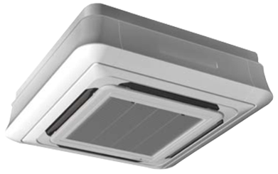

**Product Features**

* Electronic Metal Housing Box
* Self-diagnostic Function
* 15M Long Distance Airflow
* super quiet mode
* comfortable sleep mode

**Specification**

**Type** Ceiling Cassette AC

**Cooling (Btu/h)** 43000

**Voltage (V)** 220-240

**Power Input (W)** 3900

**EER (Btu/W-h-W/W)** 6.4-2.7